**PROJECT**

**SUBMITTED TO: MA’AM HUMAIRA JABEEN**

DATABASE SYSTEM 1

SYED SHAH HUSSIAN (FA21-bse-172)  
EISSA MASOOD (FA21-bse-086)  
EBADAT NISSA (FA21-bse-085)



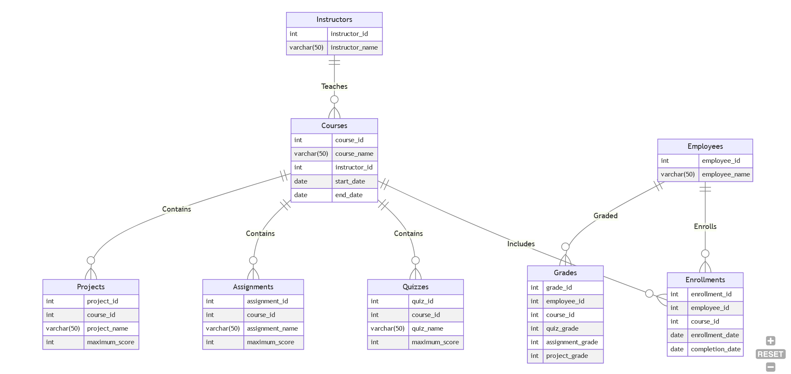**ERD**  
**CARDINALITY:**

**PRIMARY KEY + FOREIGY KEYS:**

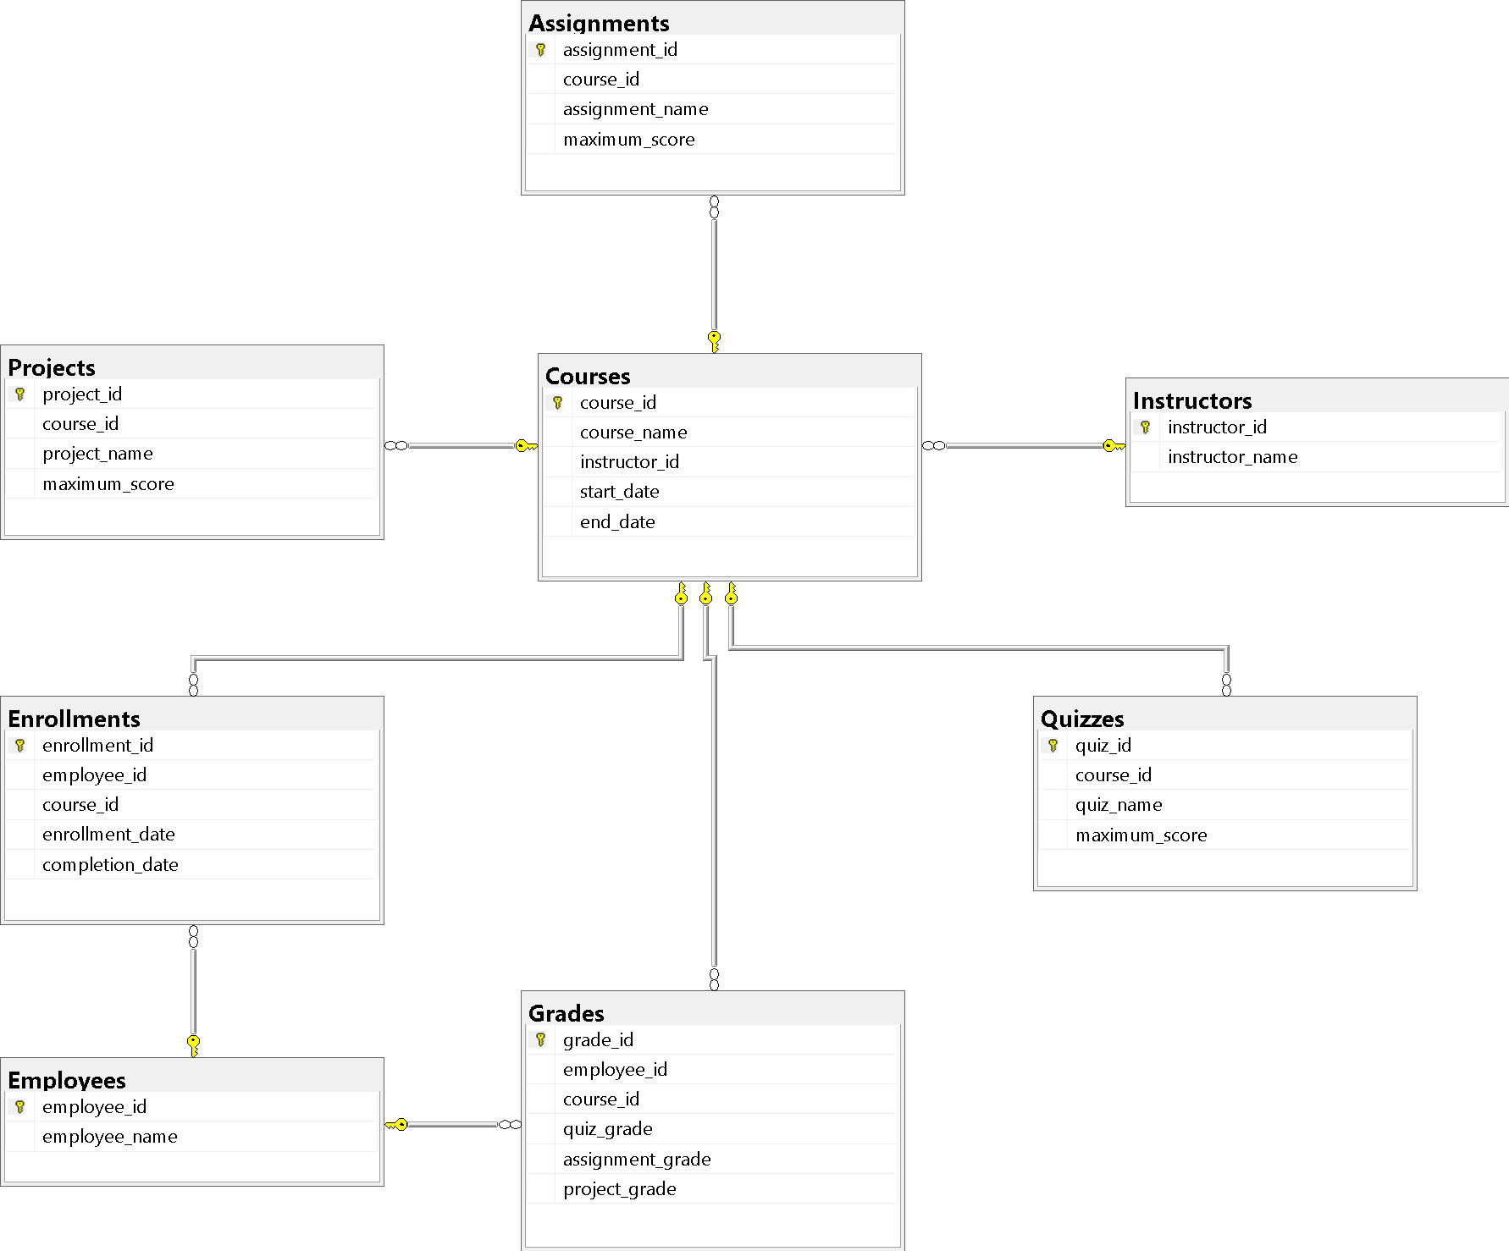

-- Create the Instructors table

CREATE TABLE Instructors (

instructor_id INT PRIMARY KEY,

instructor_name VARCHAR(50)

);

INSERT INTO Instructors (instructor_id, instructor_name)

VALUES

(1, 'Ali Khan'),

(2, 'Fatima Ahmed'),

(3, 'Mohammad Khan'),

(4, 'Sara Malik'),

(5, 'Ahmed Ali'),

(6, 'Ayesha Khan'),

(7, 'Usman Ahmed'),

(8, 'Farah Hussain'),

(9, 'Abdullah Malik'),

(10, 'Sadia Ahmed');

-- Create the Employees table

CREATE TABLE Employees (

employee_id INT PRIMARY KEY,

employee_name VARCHAR(50)

);

INSERT INTO Employees (employee_id, employee_name)

VALUES

(1, 'Mohammad Khan'),

(2, 'Fatima Ali'),

(3, 'Ahmed Malik'),

(4, 'Ayesha Ahmed'),

(5, 'Ali Khan'),

(6, 'Sara Malik'),

(7, 'Usman Ahmed'),

(8, 'Farah Khan'),

(9, 'Abdullah Malik'),

(10, 'Sadia Ahmed');

-- Create the Courses table

CREATE TABLE Courses (

course_id INT PRIMARY KEY,

course_name VARCHAR(50),

instructor_id INT,

start_date DATE,

end_date DATE,

FOREIGN KEY (instructor_id) REFERENCES Instructors(instructor_id)

);

INSERT INTO Courses (course_id, course_name, instructor_id, start_date, end_date)

VALUES

(1, 'Course 1', 1, '2023-01-01', '2023-02-01'),

(2, 'Course 2', 1, '2023-02-01', '2023-03-01'),

(3, 'Course 3', 3, '2023-03-01', '2023-04-01'),

(4, 'Course 4', 3, '2023-04-01', '2023-05-01'),

(5, 'Course 5', 5, '2023-05-01', '2023-06-01'),

(6, 'Course 6', 5, '2023-06-01', '2023-07-01'),

(7, 'Course 7', 6, '2023-07-01', '2023-08-01'),

(8, 'Course 8', 7, '2023-08-01', '2023-09-01'),

(9, 'Course 9', 7, '2023-09-01', '2023-10-01'),

(10, 'Course 10', 10, '2023-10-01', '2023-11-01'),

(11, 'Course 11', 2, '2023-10-01', '2023-11-01'),

(12, 'Course 12', 4, '2023-10-01', '2023-11-01'),

(13, 'Course 13', 8, '2023-10-01', '2023-11-01'),

(14, 'Course 14', 9, '2023-10-01', '2023-11-01');

-- Create the Enrollments table

CREATE TABLE Enrollments (

enrollment_id INT PRIMARY KEY,

employee_id INT,

course_id INT,

enrollment_date DATE,

completion_date DATE,

FOREIGN KEY (employee_id) REFERENCES Employees(employee_id),

FOREIGN KEY (course_id) REFERENCES Courses(course_id)

);

INSERT INTO Enrollments (enrollment_id, employee_id, course_id, enrollment_date, completion_date)

VALUES

(1, 1, 1, '2023-01-01', '2023-01-15'),

(2, 2, 2, '2023-02-01', '2023-02-15'),

(3, 3, 3, '2023-03-01', '2023-03-15'),

(4, 4, 4, '2023-04-01', '2023-04-15'),

(5, 5, 5, '2023-05-01', '2023-05-15'),

(6, 6, 6, '2023-06-01', '2023-06-15'),

(7, 7, 7, '2023-07-01', '2023-07-15'),

(8, 8, 8, '2023-08-01', '2023-08-15'),

(9, 9, 9, '2023-09-01', '2023-09-15'),

(10, 10, 10, '2023-10-01', '2023-10-15');

-- Create the Quizzes table

CREATE TABLE Quizzes (

quiz_id INT PRIMARY KEY,

course_id INT,

quiz_name VARCHAR(50),

maximum_score INT,

FOREIGN KEY (course_id) REFERENCES Courses(course_id)

);

INSERT INTO Quizzes (quiz_id, course_id, quiz_name, maximum_score)

VALUES

(1, 1, 'Quiz 1', 10),

(2, 2, 'Quiz 2', 10),

(3, 3, 'Quiz 3', 10),

(4, 4, 'Quiz 4', 10),

(5, 5, 'Quiz 5', 10),

(6, 6, 'Quiz 6', 10),

(7, 7, 'Quiz 7', 10),

(8, 8, 'Quiz 8', 10),

(9, 9, 'Quiz 9', 10),

(10, 10, 'Quiz 10', 10);

-- Create the Assignments table

CREATE TABLE Assignments (

assignment_id INT PRIMARY KEY,

course_id INT,

assignment_name VARCHAR(50),

maximum_score INT,

FOREIGN KEY (course_id) REFERENCES Courses(course_id)

);

INSERT INTO Assignments (assignment_id, course_id, assignment_name, maximum_score)

VALUES

(1, 1, 'Assignment 1', 10),

(2, 2, 'Assignment 2', 10),

(3, 3, 'Assignment 3', 10),

(4, 4, 'Assignment 4', 10),

(5, 5, 'Assignment 5', 10),

(6, 6, 'Assignment 6', 10),

(7, 7, 'Assignment 7', 10),

(8, 8, 'Assignment 8', 10),

(9, 9, 'Assignment 9', 10),

(10, 10, 'Assignment 10', 10);

-- Create the Projects table

CREATE TABLE Projects (

project_id INT PRIMARY KEY,

course_id INT,

project_name VARCHAR(50),

maximum_score INT,

FOREIGN KEY (course_id) REFERENCES Courses(course_id)

);

INSERT INTO Projects (project_id, course_id, project_name, maximum_score)

VALUES

(1, 1, 'Project 1', 100),

(2, 2, 'Project 2', 100),

(3, 3, 'Project 3', 100),

(4, 4, 'Project 4', 100),

(5, 5, 'Project 5', 100),

(6, 6, 'Project 6', 100),

(7, 7, 'Project 7', 100),

(8, 8, 'Project 8', 100),

(9, 9, 'Project 9', 100),

(10, 10, 'Project 10', 100);

-- Create the Grades table

CREATE TABLE Grades (

grade_id INT PRIMARY KEY,

employee_id INT,

course_id INT,

quiz_grade INT,

assignment_grade INT,

project_grade INT,

FOREIGN KEY (employee_id) REFERENCES Employees(employee_id),

FOREIGN KEY (course_id) REFERENCES Courses(course_id)

);

INSERT INTO Grades (grade_id, employee_id, course_id, quiz_grade, assignment_grade, project_grade)

VALUES

(1, 1, 1, 8, 9, 95),

(2, 2, 2, 9, 9, 85),

(3, 3, 3, 10, 10, 90),

(4, 4, 4, 7, 8, 80),

(5, 5, 5, 8, 5, 75),

(6, 6, 6, 9, 9, 70),

(7, 7, 7, 10, 5, 85),

(8, 8, 8, 7, 8, 90),

(9, 9, 9, 8, 8, 95),

(10, 10, 10, 9, 90, 100);

**--a**

SELECT * FROM Employees WHERE employee_name LIKE 'A%';

SELECT * FROM Instructors WHERE instructor_name LIKE '%Khan';

SELECT * FROM Courses WHERE course_name LIKE '%Course%';

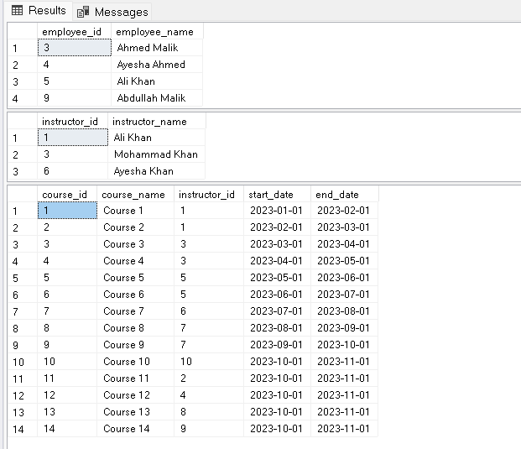

**--b**

--Query to retrieve the enrollment details of employees along with their corresponding course information:

SELECT E.employee_id, E.employee_name, C.course_id, C.course_name

FROM Employees E

INNER JOIN Enrollments EN ON E.employee_id = EN.employee_id

INNER JOIN Courses C ON EN.course_id = C.course_id;

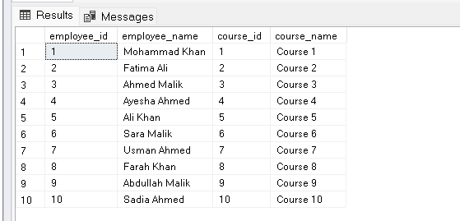

--Query to retrieve the project names and maximum scores of projects associated with each course:

SELECT C.course_name, P.project_name, P.maximum_score

FROM Courses C

LEFT JOIN Projects P ON C.course_id = P.course_id;

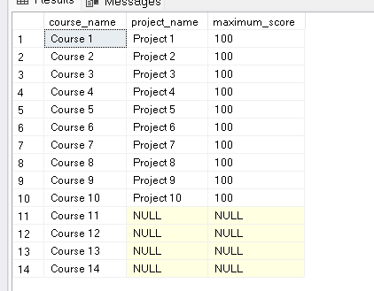

**--c**

--Get employees sorted by their names in descending order:

SELECT employee_id, employee_name

FROM Employees

ORDER BY employee_name DESC;

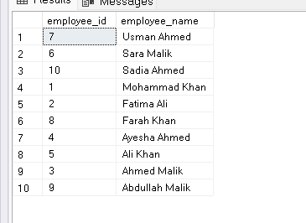

--Find quizzes sorted by the maximum score in descending order:

SELECT quiz_id, quiz_name, maximum_score

FROM Quizzes

ORDER BY maximum_score DESC;

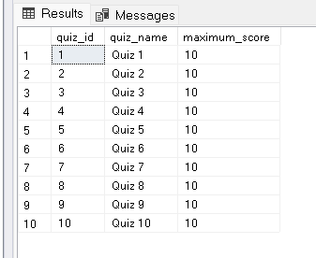

**--d**

--Query to calculate the total number of employees:

SELECT COUNT(*) AS total_employees

FROM Employees;

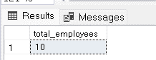

--Query to find the minimum quiz grade in a specific course:

SELECT MIN(quiz_grade) AS minimum_quiz_grade

FROM Grades

WHERE course_id = 1;

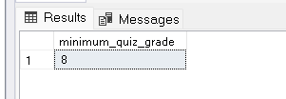

--Query to calculate the average project score for a given employee:

SELECT AVG(project_grade) AS average_project_score

FROM Grades

WHERE employee_id = 1;

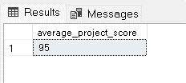

**--e**

--Query to find instructors who have taught at least 1 courses:

SELECT instructor_id, COUNT(*) AS courses_taught

FROM Courses

GROUP BY instructor_id

HAVING COUNT(*) >= 1;

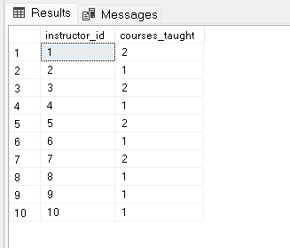

--Query to find quizzes with an average score higher than 8:

SELECT AVG(quiz_grade) AS average_score

FROM Grades

GROUP BY quiz_grade

HAVING AVG(quiz_grade) > 8;

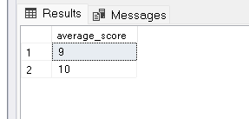

**--f**

--Query to retrieve employees who have a Project grade greater than or equal to all quiz grades:

SELECT *

FROM Grades

WHERE project_grade >= ALL (SELECT quiz_grade FROM Grades);

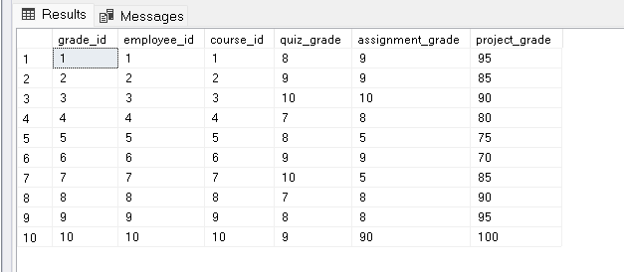

--Query to retrieve courses where the maximum project score is lesser than any quiz maximum score:

SELECT course_id

FROM Quizzes

WHERE maximum_score < ANY (SELECT maximum_score FROM Projects);

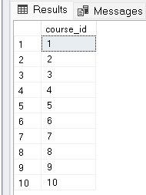

**--g**

--Query to retrieve employees who are enrolled in a course taught by instructor 'Ali Khan':

SELECT employee_id, employee_name

FROM Employees

WHERE employee_id IN (

SELECT employee_id

FROM Enrollments

WHERE course_id IN (

SELECT course_id

FROM Courses

WHERE instructor_id = (

SELECT instructor_id

FROM Instructors

WHERE instructor_name = 'Ali Khan'

)

)

);

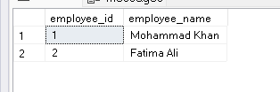

--Query to retrieve courses in which an employee achieved a perfect score (100) in the project:

SELECT course_id, course_name

FROM Courses

WHERE course_id IN (

SELECT course_id

FROM Grades

WHERE project_grade = 100

);

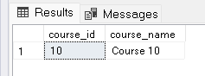

--Query to retrieve courses that have at least one employee with a grade higher than 9 in any quiz:

SELECT course_id, course_name

FROM Courses

WHERE course_id IN (

SELECT course_id

FROM Grades

WHERE quiz_grade > 9

);

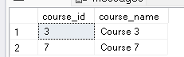

**--h**

**--SIMPLE JOIN**

--Retrieve the employees and their corresponding course names:

SELECT E.employee_id, E.employee_name, C.course_name

FROM Employees E

JOIN Enrollments EN ON E.employee_id = EN.employee_id

JOIN Courses C ON EN.course_id = C.course_id;

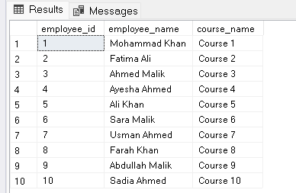

--Retrieve the instructors and the courses they teach:

SELECT I.instructor_id, I.instructor_name, C.course_name

FROM Instructors I

JOIN Courses C ON I.instructor_id = C.instructor_id;

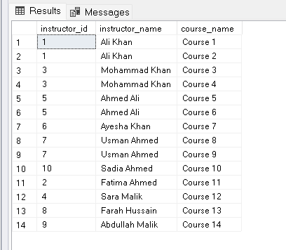

**--SORTING A JOIN**

--Retrieve the instructors and the courses they teach, sorted by the course names in ascending order:

SELECT I.instructor_id, I.instructor_name, C.course_name

FROM Instructors I

JOIN Courses C ON I.instructor_id = C.instructor_id

ORDER BY C.course_name ASC;

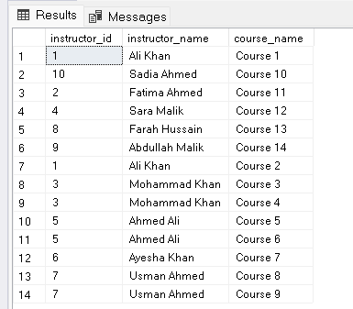

--Retrieve the employees and their corresponding course names, sorted by the employee names in descending order:

SELECT E.employee_id, E.employee_name, C.course_name

FROM Employees E

JOIN Enrollments EN ON E.employee_id = EN.employee_id

JOIN Courses C ON EN.course_id = C.course_id

ORDER BY E.employee_name DESC;

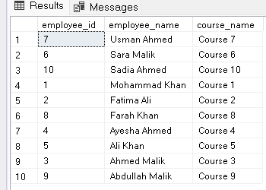

**--THREE TABLE JOIN**

--Retrieve the courses, their corresponding instructor names, and the project names associated with each course:

SELECT C.course_id, C.course_name, I.instructor_name, P.project_name

FROM Courses C

JOIN Instructors I ON C.instructor_id = I.instructor_id

JOIN Projects P ON C.course_id = P.course_id;

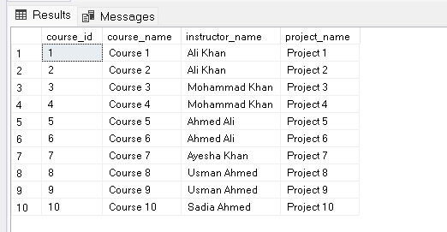

**--OUTER JOIN**

--Retrieve all employees and their corresponding course names, including employees who haven't enrolled in any course:

SELECT E.employee_id, E.employee_name, C.course_name

FROM Employees E

LEFT JOIN Enrollments EN ON E.employee_id = EN.employee_id

LEFT JOIN Courses C ON EN.course_id = C.course_id;

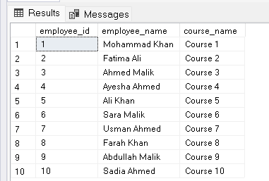

--Retrieve all courses and their corresponding instructor names, including courses without assigned instructors:

SELECT C.course_id, C.course_name, I.instructor_name

FROM Courses C

LEFT JOIN Instructors I ON C.instructor_id = I.instructor_id;

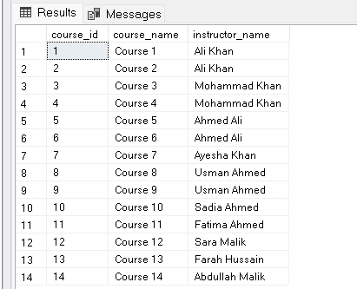

**--i CREATING UPDATABLE VIEWS**

CREATE VIEW UpdatableCoursesView AS

SELECT course_id, course_name

FROM Courses;

**--j MODIFYING VIEWS**

ALTER VIEW UpdatableCoursesView AS

SELECT course_id, course_name, instructor_id, start_date, end_date

FROM Courses;

SQL Server does not support directly modifying the structure of a view using ALTER VIEW instead, we need to drop and recreate the view with the desired changes.

================================= **END ☺** ==================================